**COIT11237 Database Design & Implementation**

# QProperty database

# Part A – SQL Queries

**Questions**

1. For inspections, show details of properties that have been inspected but did not have comments.

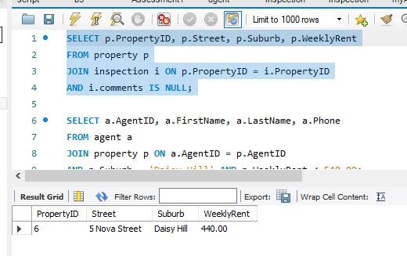

1. Show the details of agent(s) who managed the properties in the suburb – *Daisy Hill* with the weekly rent less than $540.

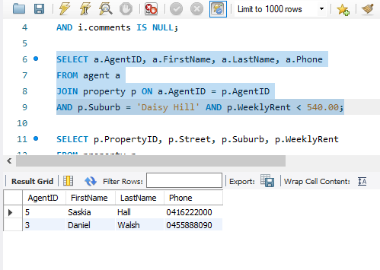

1. Show properties that have not been inspected.

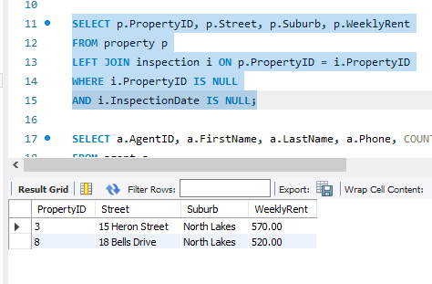

1. Which agent(s) manages two or more properties? Include the agent’s ID, name, phone, and the number of properties managed.

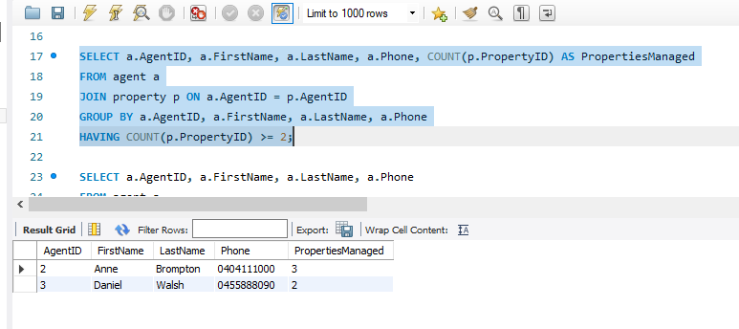

1. Show the names of agents and their managed properties for which the weekly rents are lower than the average weekly rent recorded in the system.

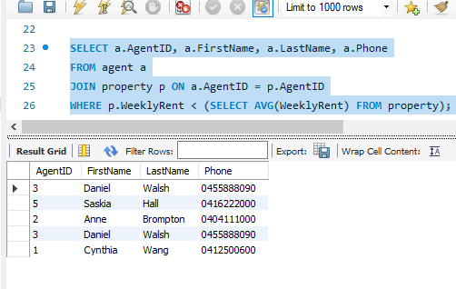

1. In the past year, how many inspections have been made?

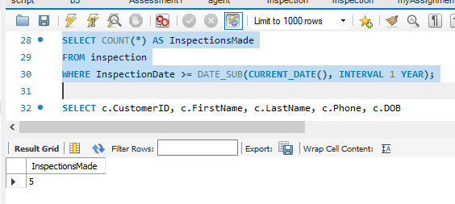

1. Find out which customer(s) who has/have the highest number of inspections. Display their ID, name, phone, and date of birth.

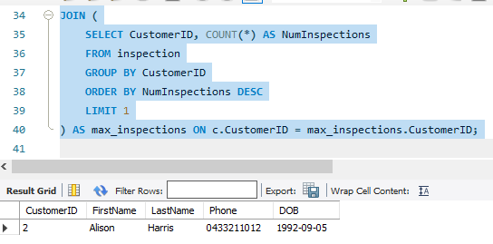

1. List the details of those repair jobs that have been completed with the charge between $1000 and $3000. These details should include the job number, job description, charge, property address, and corresponding managing agent name. Hint: understand how the BETWEEN operator works.

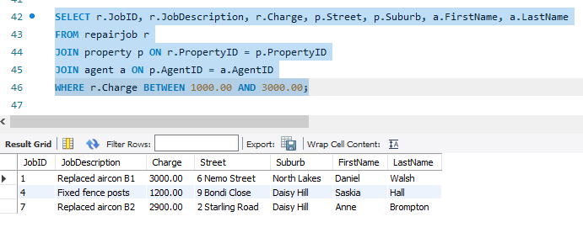

1. List the properties that have repair jobs and what the total cost is for each property.

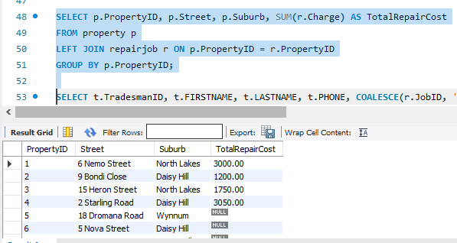

1. Show the ID, name, and phone number of tradesperson along with the repair jobs which have been completed. Also include the tradesperson who have not done any repair jobs. Display the results in ascending order of the tradesperson’s surname.

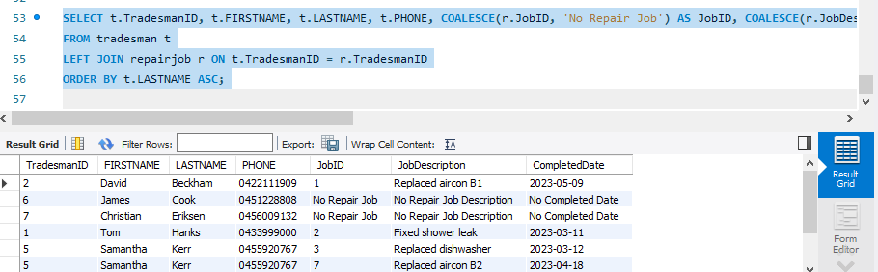

# Part B – Screenshots and Query Analysis

# Question 1

It is possible to accomplish this by utilising an LEFT JOIN procedure between the property table and the inspection table. These tables can be left joined, which allows us to include all of the properties from the property table. This is true regardless of whether or not the inspection table contains records that correspond to the properties in question. After that, we apply a filter to the results, and we only include rows in the inspection table that do not have a match. This is the point at which the inspection is performed.PropertId is not present. Through this process, it is ensured that properties that have not been inspected are retrieved.

Alternative methodology 1:

Using LEFT JOIN and IS NULL:

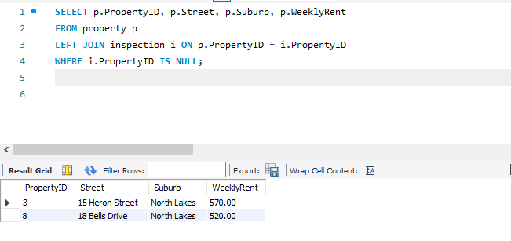

Alternative methodology 2:

Using subquery with NOT IN operator:

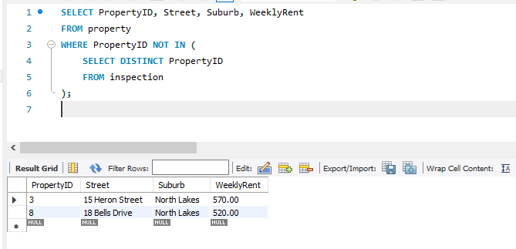

# Question 2

Modification of Data:

